**PRACTICAL 4**

**AIM:** To create the following topology

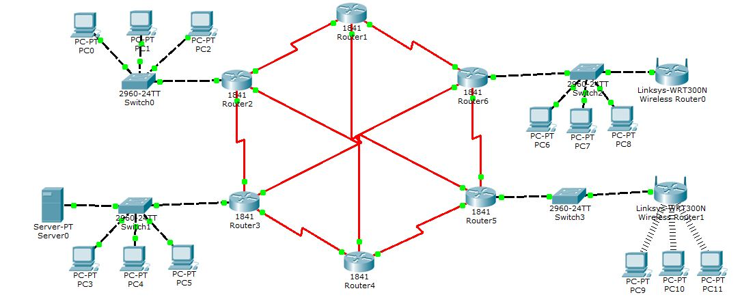

**PC0:**

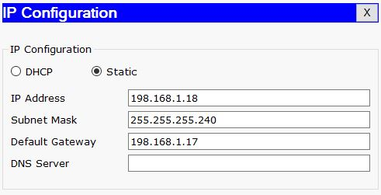

**PC1:**

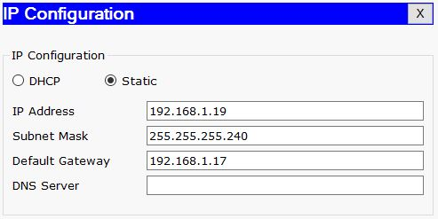

**PC2:**

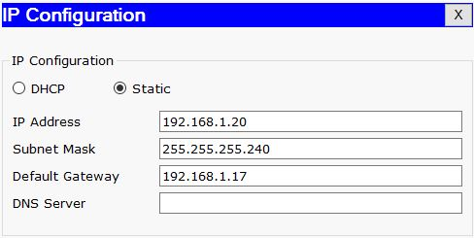

**PC3:**

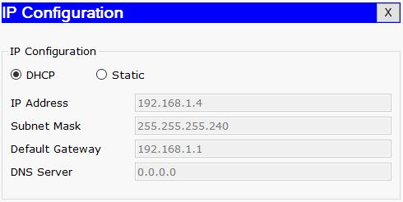

**PC4:**

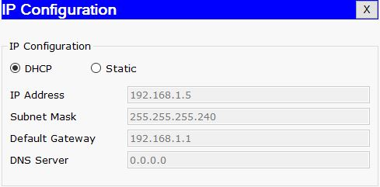

**PC5:**

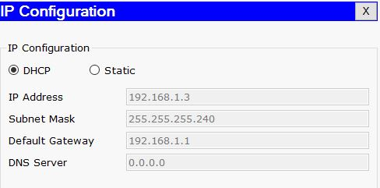

**PC6:**

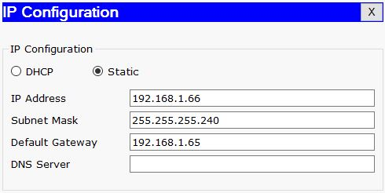

**PC7:**

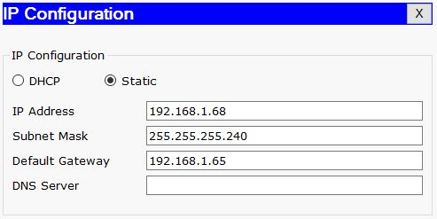

**PC8:**

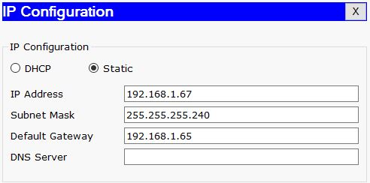

**PC9:**

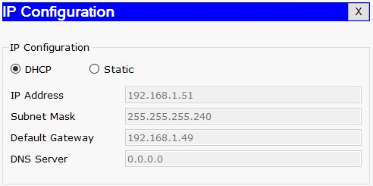

**PC10:**

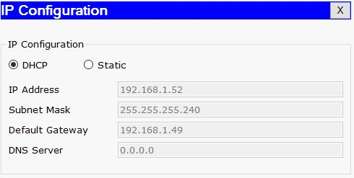

**PC11:**

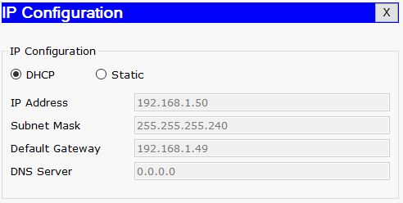

**Server Configuration:**

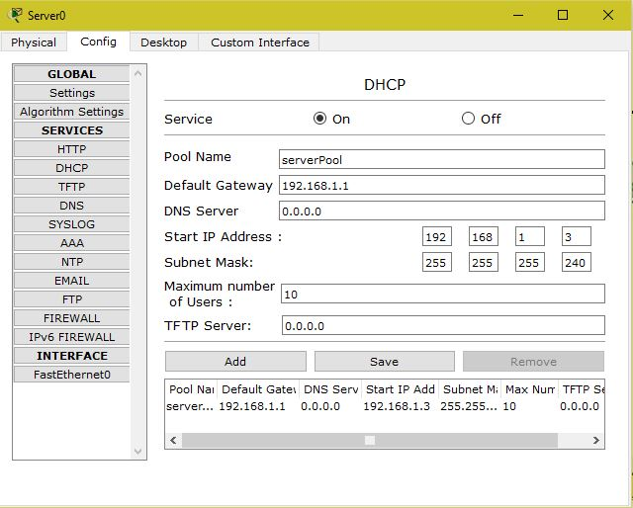

**Linksys Router Configuration:**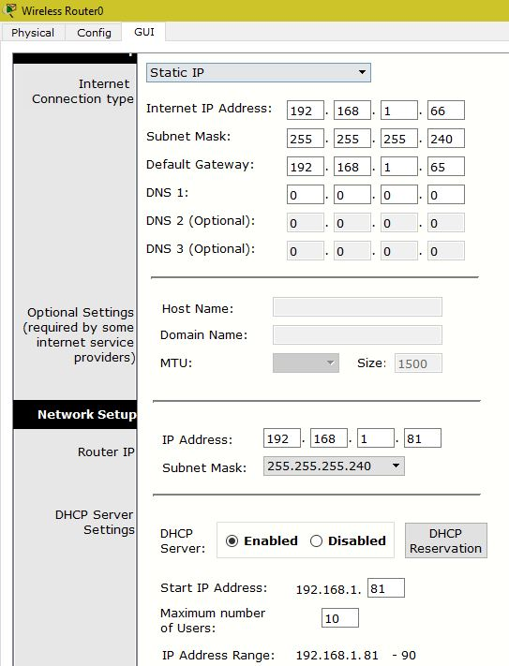

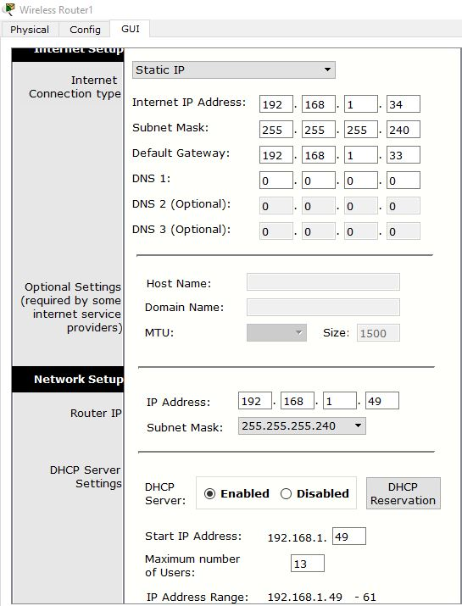

**Router Configuration:**

**Router1:**

Router>enable

Router#configure terminal

Enter configuration commands, one per line. End with CNTL/Z.

Router(config)#interface Serial0/1/0

Router(config-if)#ip address 192.168.1.98 255.255.255.240

Router(config-if)#clock rate 72000

Router(config-if)#no shutdown

Router(config-if)#

Router(config-if)#exit

Router(config)#interface Serial0/1/1

Router(config-if)#ip address 192.168.1.178 255.255.255.240

Router(config-if)#clock rate 72000

Router(config-if)#no shutdown

Router(config-if)#

Router(config-if)#exit

Router(config)#interface Serial0/0/1

Router(config-if)#ip address 192.168.1.227 255.255.255.240

Router(config-if)#clock rate 72000

This command applies only to DCE interfaces

Router(config-if)#no shutdown

**Router2:**

Router>enable

Router#configure terminal

Enter configuration commands, one per line. End with CNTL/Z.

Router(config)#interface FastEthernet0/0

Router(config-if)#ip address 192.168.1.17 255.255.255.240

Router(config-if)#no shutdown

Router(config-if)#

%LINK-5-CHANGED: Interface FastEthernet0/0, changed state to up

%LINEPROTO-5-UPDOWN: Line protocol on Interface FastEthernet0/0, changed state to up

Router(config-if)#exit

Router(config)#interface Serial0/1/0

Router(config-if)#ip address 192.168.1.97 255.255.255.240

Router(config-if)#no shutdown

Router(config-if)#

%LINK-5-CHANGED: Interface Serial0/1/0, changed state to up

Router(config)#interface Serial0/0/1

Router(config-if)#ip address 192.168.1.113 255.255.255.240

Router(config-if)#clock rate 72000

Router(config-if)#no shutdown

Router(config-if)#

Router(config-if)#exit

Router(config)#interface Serial0/1/1

Router(config-if)#ip address 192.168.1.129 255.255.255.240

Router(config-if)#clock rate 72000

Router(config-if)#no shutdown

**Router3:**

Router>enable

Router#configure terminal

Enter configuration commands, one per line. End with CNTL/Z.

Router(config)#interface FastEthernet0/0

Router(config-if)#ip address 192.168.1.1 255.255.255.240

Router(config-if)#no shutdown

Router(config-if)#

%LINK-5-CHANGED: Interface FastEthernet0/0, changed state to up

%LINEPROTO-5-UPDOWN: Line protocol on Interface FastEthernet0/0, changed state to up

Router(config-if)#exit

Router(config)#interface Serial0/0/1

Router(config-if)#ip address 192.168.1.130 255.255.255.240

Router(config-if)#clock rate 72000

This command applies only to DCE interfaces

Router(config-if)#no shutdown

Router(config-if)#no shutdown

Router(config-if)#

%LINK-5-CHANGED: Interface Serial0/0/1, changed state to up

%LINEPROTO-5-UPDOWN: Line protocol on Interface Serial0/0/1, changed state to up

Router(config-if)#exit

Router(config)#interface Serial0/1/0

Router(config-if)#ip address 192.168.1.145 255.255.255.240

Router(config-if)#clock rate 72000

Router(config-if)#no shutdown

Router(config-if)#

Router(config-if)#exit

Router(config)#interface Serial0/0/0

Router(config-if)#ip address 192.168.1.161 255.255.255.240

Router(config-if)#clock rate 72000

Router(config-if)#no shutdown

%LINK-5-CHANGED: Interface Serial0/0/0, changed state to up

%LINEPROTO-5-UPDOWN: Line protocol on Interface Serial0/0/0, changed state to up

**Router4:**

Router>enable

Router#configure terminal

Enter configuration commands, one per line. End with CNTL/Z.

Router(config)#interface Serial0/0/0

Router(config-if)#ip address 192.168.1.162 255.255.255.240

Router(config-if)#clock rate 72000

This command applies only to DCE interfaces

Router(config-if)#no shutdown

Router(config-if)#

%LINK-5-CHANGED: Interface Serial0/0/0, changed state to up

%LINEPROTO-5-UPDOWN: Line protocol on Interface Serial0/0/0, changed state to up

Router(config-if)#exit

Router(config)#interface Serial0/1/1

Router(config-if)#ip address 192.168.1.177 255.255.255.240

Router(config-if)#clock rate 72000

This command applies only to DCE interfaces

Router(config-if)#no shutdown

Router(config-if)#

%LINK-5-CHANGED: Interface Serial0/1/1, changed state to up

%LINEPROTO-5-UPDOWN: Line protocol on Interface Serial0/1/1, changed state to up

Router(config-if)#exit

Router(config)#interface Serial0/1/0

Router(config-if)#ip address 192.168.1.193 255.255.255.240

Router(config-if)#clock rate 72000

Router(config-if)#no shutdown

**Router5:**

Router>enable

Router#configure terminal

Enter configuration commands, one per line. End with CNTL/Z.

Router(config)#interface FastEthernet0/0

Router(config-if)#ip address 192.168.1.33 255.255.255.240

Router(config-if)#no shutdown

Router(config-if)#

%LINK-5-CHANGED: Interface FastEthernet0/0, changed state to up

%LINEPROTO-5-UPDOWN: Line protocol on Interface FastEthernet0/0, changed state to up

Router(config-if)#exit

Router(config)#interface Serial0/1/0

Router(config-if)#ip address 192.168.1.114 255.255.255.240

Router(config-if)#clock rate 72000

This command applies only to DCE interfaces

Router(config-if)#no shutdown

Router(config-if)#

%LINK-5-CHANGED: Interface Serial0/1/0, changed state to up

%LINEPROTO-5-UPDOWN: Line protocol on Interface Serial0/1/0, changed state to up

Router(config-if)#exit

Router(config)#interface Serial0/0/1

Router(config-if)#ip address 192.168.1.194 255.255.255.240

Router(config-if)#clock rate 72000

This command applies only to DCE interfaces

Router(config-if)#no shutdown

Router(config-if)#

%LINK-5-CHANGED: Interface Serial0/0/1, changed state to up

%LINEPROTO-5-UPDOWN: Line protocol on Interface Serial0/0/1, changed state to up

Router(config-if)#exit

Router(config)#interface Serial0/1/1

Router(config-if)#ip address 192.168.1.209 255.255.255.240

Router(config-if)#clock rate 72000

Router(config-if)#no shutdown

**Router6:**

Router>enable

Router#configure terminal

Enter configuration commands, one per line. End with CNTL/Z.

Router(config)#interface FastEthernet0/0

Router(config-if)#ip address 192.168.1.65 255.255.255.240

Router(config-if)#no shutdown

Router(config-if)#

%LINK-5-CHANGED: Interface FastEthernet0/0, changed state to up

%LINEPROTO-5-UPDOWN: Line protocol on Interface FastEthernet0/0, changed state to up

Router(config-if)#exit

Router(config)#interface Serial0/0/0

Router(config-if)#ip address 192.168.1.146 255.255.255.240

Router(config-if)#no shutdown

Router(config-if)#

%LINK-5-CHANGED: Interface Serial0/0/0, changed state to up

%LINEPROTO-5-UPDOWN: Line protocol on Interface Serial0/0/0, changed state to up

Router(config-if)#exit

Router(config)#interface Serial0/1/0

Router(config-if)#ip address 192.168.1.210 255.255.255.240

Router(config-if)#no shutdown

Router(config-if)#

%LINK-5-CHANGED: Interface Serial0/1/0, changed state to up

%LINEPROTO-5-UPDOWN: Line protocol on Interface Serial0/1/0, changed state to up

Router(config-if)#exit

Router(config)#interface Serial0/0/1

Router(config-if)#ip address 192.168.1.226 255.255.255.240

Router(config-if)#no shutdown

Router(config-if)#

%LINK-5-CHANGED: Interface Serial0/0/1, changed state to up

%LINEPROTO-5-UPDOWN: Line protocol on Interface Serial0/0/1, changed state to up

**IP Routes:**

**For all routers:**

Router(config)#router rip

Router(config-router)#network 192.168.1.0

**Output:**

